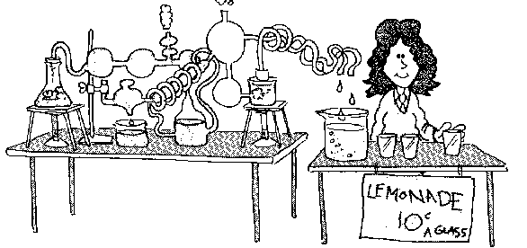
CHEMISTRY - Activities

1. STATES OF MATTER

Solids, Liquids and Gases

1. Name the three states of matter. ......................................... ............................................. ...................................
2. Give examples of three solids, three liquids and three gases in the table below:
Solids | Liquids | Gases

3. Activity 1. - Properties of solids, liquids and gases
i) Examine the three solids provided, and answer the questions in the "Solid" column in the results table.
ii) For each of the liquids provided, do the following experiments, and then answer the questions in the "Liquid"
column in the results table:
a) Pour 50 mL of the liquid into a small beaker. Pour this liquid into a small conical flask, then
pour it into a measuring cylinder.
b) Draw some of the liquid into a syringe. Hold your finger over the end of the syringe, and try
to push in the plunger.
iii) Do the following experiments, and then answer the questions in the "Gas" column in the results table:
a) Examine the gas jar of the brown gas, nitrogen dioxide.
b) Place an empty gas jar with its mouth down, over the top of the filled gas jar and remove the
cover slip. Observe what happens to the brown gas.
c) In the fume hood, pour the gas out of one of the gas jars.
d) Pull out the plunger of a syringe so that a volume of air is in the syringe. Hold your finger over the end of the syringe. Try to push the plunger in.

Results

Property | Solid | Liquid | Gas
Does sample have fixed shape or does it take the shape of the container?
Is the volume constant or does sample spread out to occupy the whole container?
Can the sample be compressed?

Is the sample able to flow? |  |  | 

4. Choose your answers for the following questions from those given in the box below:

oxygen copper ethanol (methylated spirits) helium ice

a) Which substances are highly compressible?
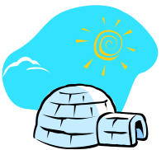
b) Which substances have a constant shape?
c) Which substances change volume when you put them in a different container?
d) Which substances can be poured slowly out of a beaker?

Changes in State

5. Activity 2. - Changes in state
i) Put a very small amount of wax on the end of a metal spatula.
Gently heat the wax in a Bunsen flame until a change in state occurs. Allow the wax to cool.
a) What is the state of wax at room temperature? .........................................................
b) Did the wax form a solid, liquid or gas when it was heated? .............................................
c) What is the name of the change in state that occurred when the wax was heated? ..........................................
d) What is the name of the change in state that occurred when the melted wax was allowed to cool?
...................................................

ii) Heat some water in the beaker until a rapid change in state begins to occur.
a) What state does the liquid water form at 100ºC? .............................................
b) What is the name of the change in state that occurs when water is heated to 100ºC? .......................................

iii) With tongs, carefully hold a cold watch glass above the boiling water for several minutes.
a) Describe what happens on the underside of the watch glass ......................................................................... ..........................................................................................................................................................................................
b) What is the name of the change in state that occurs on the cold watch glass? .....................................................

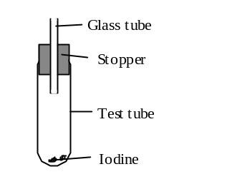
6. Activity 3. - Sublimation
i) Set up the apparatus shown on the right, and place a vary small
amount of iodine in the bottom of the test tube.
ii) Very gently heat the iodine until a purple gas is formed.
iii) Allow the test tube to cool and observe the contents.

Questions:
a) Describe what happens to the iodine during the heating. .................................................................................

.......................................................................................................................................................................................

b) Describe what happens to the iodine when it cools down ..................................................................................

......................................................................................................................................................................................

c) What is the name of the change in state that occurred when the iodine was heated? ............................................
d) Name the change in state that occurred near the top of the test tube during cooling? .........................................
7. What are the names given to the following changes in state?
When a substance changes from:
a solid to a liquid ...................................................……..
a liquid to a gas ..............................................................
a gas to a liquid ..............................................................
a liquid to a solid ..............................................................
a solid to a gas ...............................................................
a gas to a solid ................................................................
8. The water on the earth is always moving from one place to another and changing from one state to another. These changes are known as the water cycle. Complete the gaps in the following diagram showing the water cycle.
If cold enough, the liquid water will ...................
to form ice and snow.

When the gaseous water
cools, it ................................ to form droplets of liquid water in clouds.
wind

rain, snow or hail

Liquid water ................................ from the sea, soil, plants and lakes to form gaseous water in the air.

lake
non-porous rock
sea

Melting Point and Boiling Point

9. Activity 4. - Determination of melting points and boiling points

i) Half fill a beaker with water and heat the water until it is boiling.
Turn off your Bunsen burner - methylated spirits in very flammable i.e. it will burst into flames if put near a flame..

ii) Pour some methylated spirits (ethanol) into a test tube until it is about one quarter full.
Place the test tube in the beaker of hot water from step i).
Determine the boiling point of ethanol and record it in the table below.

iii) Using the same beaker of hot water, heat it to boiling again.
Place a test tube containing naphthalene in the beaker.
Determine the melting point of naphthalene and record it in the table below.

Boiling point of ethanol |  |  | Melting point of naphthalene
Boiling point of water |  |  | Melting point of ice

10. Look up the melting and boiling points of the following substances in a Chemistry data book:
iron, gold, sodium chloride, ethanol (alcohol), sand (silicon dioxide), diamond (carbon), water,
aluminium, oxygen , carbon dioxide, nitrogen, polythene (plastic).
Record the information in the table below, in order of highest melting point to lowest melting point.

Substance | Melting point (ºC) | Boiling point (ºC)

11. a) To what temperature would you have to heat an iron nail to melt it? .......................
b) If you heated some aluminium to 1000ºC, would it be a solid, a liquid or a gas? ........................
c) If you cooled some oxygen, at what temperature would it become a liquid? ..........................
d) The hot plate on an electric stove reaches a temperature of about 300ºC. If you dropped some salt on the hot plate, would the salt melt?
.................................

12. Explain, in terms of melting points, why cake tins are made from iron or aluminium and not from plastic.
........................................................................................................................................................................................
........................................................................................................................................................................................

REVIEW QUESTIONS

13. At room temperature (that is, at about 25ºC), what is the state of each of the following substances?

Substance | State | Substance | State | Substance | State
water |  | sugar |  | carbon dioxide
iron |  | petrol |  | sand (silicon dioxide)
oxygen |  | nitrogen |  | salt (sodium chloride)

14. To which state or states of matter do the following substances belong?
a) chlorine is easily compressed and takes the shape of its container. ...................................
b) magnesium is not compressible. It has fixed shape and fixed volume. ...................................
c) ethanol is not compressible. It takes the shape of the container ...................................

15. Name these changes in state:
a) solid to liquid ...................................................................
b) solid to gas ..................................................................
c) liquid to gas ...................................................................
d) gas to liquid ...................................................................
e) liquid to solid ...................................................................

16. Name the change in state that occurs when:
a) dew forms on the grass ...................................................................
b) a bottle of perfume is opened and can be smelt on the other side of the room ....................................
c) a puddle of water on a bitumen road disappears ...................................................................
d) naphthalene flakes (moth balls) are placed in a suitcase of clothes and gradually disappear ................................................
e) water is heated until it changes into steam ...................................................................
f) ice is allowed to heat up until it becomes water ...................................................................

17. Fill in the gaps:
Most matter on Earth can be classified into one of three groups - s...................... , l.............................. or g.......... . These three groups are commonly known as the three s...................... o... m.................................
The three states of matter have differing properties. A solid has a f........................ volume, a rigid s.......................... and it c........ .......... be compressed. A liquid has a fixed v........................... , it takes the s.............................. of the container, and it can not be c.................................................... . A gas spreads out to occupy the whole c............................................ , it takes the s................................ of the container, and it c........... be compressed. A l.................................. and a g............ can flow, however, a s........................... cannot flow.

18. Use the data in the following table to answer the questions below:
Substance | Melting point (ºC) | Boiling point (ºC)
water  benzene  copper  ethanol  oxygen | 0  6  1083  - 117  -219 | 100  80  2596  79  -183

a) At what temperature does copper change from a solid to a liquid? ................................
b) At what temperature does ethanol boil? ................................
c) Which substance in the table has the lowest melting point? ................................
d) Which substance would have to be heated to the highest temperature before it melts? .................................

For questions 19 - 25 choose the best alternative. You may need to use your Science Dictionary to answer some of these questions.

19. Which of the following substances is a liquid at room temperature?
A mercury B copper C chlorine D helium

20. Clouds are composed of
A liquid air B solid water (ice) C tiny droplets of water
D gaseous water E cotton wool

21. Which has the highest melting point?
A butter B ice C plastic D steel

22. It is not safe to heat ethanol (methylated spirits) with a Bunsen burner because
A a Bunsen burner should not be used to heat liquids
B ethanol reacts with the glass from which beakers are made
C ethanol has a boiling point less than that of water
D ethanol is a substance which very readily catches fire when heated with a flame.

23. It would not be suitable to make the racks (trays) for an oven from PVC plastic because PVC plastic
A cannot be moulded into the required shape B has a lower melting point than about 150⁰C
C is not silver in colour D does not conduct electricity or heat.

24. Which of the following is not an example of vaporisation?
A The drying of wet clothes B Water boiling
C Making dried fruit e.g. sultanas D Making ice

25. Liquid nitrogen is often used to quickly freeze and store living tissue or to destroy ("burn" off) tiny skin cancers.
The temperature of liquid nitrogen is approximately
A 100ºC B 0ºC C -50ºC D -200ºC

2. THE PARTICLE THEORY OF MATTER

1. Everything is made up of extremely tiny particles. In a drop of water there would be about
100 000 000 000 000 000 000 000 particles.
Approximately how many particles would you expect to be in an eye lash?
A 1 particle
B 100 particles
C 100 000 particles
D 10 000 000 000 000 000 000 000 particles

2. Which of the following diagrams would represent - the particles in a solid
- the particles in a liquid
- the particles in a gas?

............................................ ...................................... ..........................................

3. Complete the following table by choosing the correct word/s from the list in the box

 | Solid | Liquid | Gas
Distance between
particles
Arrangement of
particles
Movement of
particles
Forces between
particles

vibrating in fixed positions very close orderly arrangement close together
very far apart disorderly arrangement free to move very strong
move independent of one another extremely weak disorderly arrangement strong

4. Choose the correct explanation for each of the following properties:

PROPERTY | EXPLANATION OF PROPERTY
1. Solids have a rigid shape | A There are almost no forces between the gas particles  and so the particles are able to spread as far apart as  possible
2. Gases occupy the whole volume of the  container | B The particles of a liquid are already close together and  cannot be pushed closer together
4. Liquids are not compressible | C The forces between the particles of liquids and solids  are stronger than those between gas particles, so the  liquid/solid particles are held in a constant volume
3. Liquids and solids have a constant volume,  but gases do not. | D The forces between the particles are very strong and  so the particles are held tightly together.

5. Write an explanation, in terms of the Particle Theory of Matter, to explain the following properties.
a) A gas is highly compressible.
............................................................................................................................................................
............................................................................................................................................................
b) Liquids do not have a fixed shape.
............................................................................................................................................................
............................................................................................................................................................

REVIEW QUESTIONS

6. In which of the following substances, at room temperature, are the particles closest together?
oxygen gas helium salt

7. In which of the following substances, at room temperature, are the particles arranged in an orderly arrangement?
water nitrogen copper carbon dioxide

8. In which of the following substances, at room temperature, are the attractive forces between the particles the weakest?
oxygen petrol silver gold

9. Which of the two diagrams below represents
a) the change in state that occurs when a solid is heated? ..........................
b) the change in state that occurs when a liquid is heated? ..........................
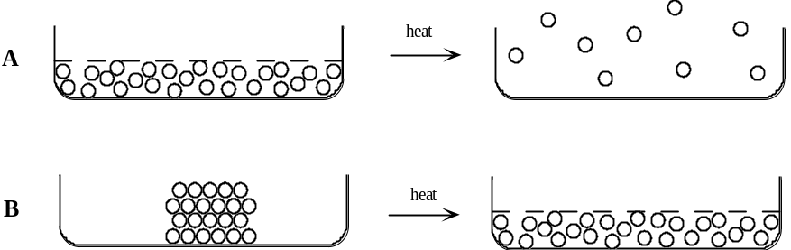

10. Fill in the gaps in the following sentences:
A .......................... consists of particles held rigidly in place in a fixed structure. Although the particles d...... n........... move about from place to place, they do v.................................. When we heat a solid, the particles absorb the heat and vibrate m................. vigorously. Eventually the vibrations become so vigorous that the structure b................... up and the particle start to m................... about in random motion. That is, the solid m..................... to form a l......................... As we keep supplying heat, the liquid particles travel f......................... and f.......................... and move f........................... apart. At a particular temperature called the b........................... p....................... the particles move so far apart that the liquid changes to a g............. At this temperature, the f..................... of attraction between the particles are too w................ to hold the particles together.

11. Indicate whether each of the following statements is true or false.
a) The particles of a gas are far apart and move with random motion.
b) The particles of a solid are stationary.
c) The particles of a solid are held in a rigid structure.
d) There are strong forces of attraction between the particles of a gas.
e) A gas can be compressed because there is a lot of space between the particles.
f) When a substance is heated its particles move faster.
g) A solid has a fixed shape because there are only weak forces between the particles.
h) A solid cannot be compressed because the particles are already very close together.
i) A solid has a fixed shape because there are very weak forces between the particles and they are very far
apart.
j) When a liquid is cooled, its particles move faster.
k) The particles in a gas are closer together than the particles in a liquid.

12. Fill in the gaps:
The properties of matter can be explained in terms of the particle theory of matter. First, a solid has a fixed s.................. and v...................... because the particles in a solid are packed t................... together and so they c.......... ......... move freely. In the liquid state, the particles are still c..................... together, thus liquids have a fixed v......................... But the particles in a liquid are able to m.................. around or slide over one another because of the w.................... forces of attraction between the particles. This would allow the liquid to take the s....................... of the container. In a gas, there is a great deal of e.................... space between the particles and they c........... move around freely because there are insignificant f.............. of a........................ between the particles This is why a gas can be c..................................... and why it f............. any container.

For questions 13 - 16, choose the best alternative.

13. In which of the following substances are the particles most strongly attracted to each other at 20°C?
A cooking oil B iron C air D shampoo

14. When steam is cooled from 100⁰C to 95⁰C and it condenses, its particles
A move closer together B have weaker attractive forces between them
C move faster D become larger

15. The volume of 20 g of liquid water is approximately 20 mL. When 20 g of water is converted to steam, it has a
volume of approximately 30 000 mL. This difference in volume is due to the fact that
A steam particles are larger than water particles
B 20 g of steam contains more particles than 20 g of liquid water
C the space between the particles is greater in steam than in liquid water
D steam particles have stronger forces of attraction between them

16. Which of the following is not an observation?
A A piece of granite has a constant shape and volume
B Water has a boiling point of 100ºC
C Oxygen has no odour
D In an iron nail, the particles of iron are very close together.

3. MIXTURES & SOLUTIONS

1. Activity 5. - Soluble and insoluble substances

i) Add a small amount of each of the substances, given in the table, to separate test tubes. Add some water and then
shake.
ii) Record your observations in the results table and also record which substances are soluble and which are insoluble.

Results

Substance | Observations when added to water | Soluble or insoluble?
salt
sugar
sand
wax
copper sulfate
nickel chloride
calcium carbonate (limestone)
copper carbonate
oil

2. When first mixed and shaken, which of the above mixtures formed
- a solution? ...........................................................................................................................
- a suspension? ...........................................................................................................................
- a sediment? ...........................................................................................................................

3. Fill in the gaps in the following sentences. Choose your words from the list given in the box below.

solute solvent solution dissolves sediment
dissolve sediment dissolve suspension

When sugar is added to water and the water is stirred, the sugar .............................. and a ............................. is formed. In this solution, the water is said to be the ..........................and the sugar is said to be the...........................
When sand is added to water, the sand does not ......................... because it is ................................. The sand settles to the bottom of the container and forms a .......................................
When a powdered insoluble solid like calcium carbonate is added to water, it does not ..................................and
it may stay suspended in the water, that is, it may form a ...............................................
4. For each of the following solutions, name the solvent and the most abundant solutes:
Solution | Solvent | Solutes (most abundant)
sea water
Perth's drinking water
lemonade
cordial
rain water
bore water
black tea
black coffee

5. Activity 6. - Solubility in hot water

i) Design and write a method for an experiment to test the hypothesis that "copper sulfate is more soluble in hot water than in cold water".
ii) Carry out your experiment and record your results.
iii) Do your results support the hypothesis?
Method
.......................................................................................................................................................................................................
......................................................................................................................................................................................................
.......................................................................................................................................................................................................
.......................................................................................................................................................................................................
.......................................................................................................................................................................................................
Results
.......................................................................................................................................................................................................
......................................................................................................................................................................................................
......................................................................................................................................................................................................

6. Use the Particle Theory of Matter to explain what happens when a solid dissolves in water. Include diagrams.
.......................................................................................................................................................................................................
.......................................................................................................................................................................................................
.......................................................................................................................................................................................................

7. Name one water-insoluble substance and two water-soluble substances that cause pollution or damage to our environment.

Insoluble ........................................ Soluble ............................................... and ........................................................

REVIEW QUESTIONS
For questions 8. to 17. choose the best answer:

8. When a substance dissolves, its particles
A float to the top B spread through the liquid C sink to the bottom

9. Substances which dissolve in water are said to be
A soluble B solutions C sediments D solvents

10. If there is a layer on the bottom of a liquid it is called a
A sediment B solution C suspension D solvent

11. When sugar dissolves in water it forms a
A model B solution C suspension D sediment

12. We know that a solid will dissolve in water if, after it is shaken with water,
A a layer appears on the top of the water B much or all of the solid has disappeared
C the water becomes cloudy

13. When an insoluble solid is shaken with water
A all of the solid disappears B some of the solid disappears
C none of the solid disappears

14. Solutions are always
A cloudy B coloured C clear D colourless

15. When a soluble solid is mixed with water the attractive forces between the solid's particles
A disappears immediately
B becomes much stronger
C no longer holds the particles together

16. If solid iodine is dissolved in methylated spirits, the methylated spirits is the
A solvent B solute C solution

17. When stones are mixed with water they form a
A solution B suspension C sediment

18. A teaspoonful of a substance was shaken with water and allowed to stand. A small amount (about a quarter of a teaspoonful) of the substance formed a layer on the bottom of the container. The liquid above the layer was clear.

Four conclusions drawn from the above experiment are stated below.
a) The substance was soluble in water ..............................................
b) A suspension was formed ..............................................
c) A solution was formed ..............................................
d) A sediment was formed ..............................................
Decide whether each conclusion is true, false or whether there is insufficient evidence for you to decide whether the conclusion is true or false.

19. Sugar in hot coffee: what is the solute and what is the solvent in this solution?
solute: ..................................... solvent: .......................................

20. Classify each of the following as a mixture, suspension or solution :
Weak black tea ...................................... Lemonade ..........................................
Freshly squeezed orange juice ...................................... Muddy water ..........................................
Chocolate milk ...................................... Tap water ...........................................
21. Are the following soluble or insoluble in water?
Sugar .......................... Oil .............................. Vinegar ............................
Salt .......................... Instant coffee ........................ Butter .............................

22. Label each of the following as true or false:
a) A solution consists of a solute and a solvent
b) Fish can live in the ocean because oxygen is soluble in water.
c) In making a solution, a solvent is dissolved in a solute
d) Salt is less soluble in hot water than in cold water
e) An insoluble solid forms a solution when added to a solvent.
f) A suspension is sometimes formed when an insoluble solid is added to water.
g) When a solid dissolves in water, the grain's of solid become too small to be seen.
h) A sediment forms when an insoluble solid sinks to the bottom of a liquid.

23. Choose words from the following list to fill in the gaps in the following sentences
see solute solution soluble insoluble suspension dissolves cold
hot solvent salt solvent not dissolve solvents gases water

When salt is added to water, it ............................. in the water. It is no longer possible to ................ the salt but it is, of course, still there. The substance which dissolves (...................... in this case) is called the .............................. . The substance which does the dissolving ( .......................... in this case) is called the ...................................and the resulting mixture is called a ...................................... . Salt is said to be ............................... in water.
Chalk is ...................................... in water: in other words, it does ................................................ in water. If fine chalk powder is added to water and the mixture stirred, the mixture becomes cloudy. That is, a ................................. forms.
There are other common solvents including ethanol, trichloroethane and turpentine. If a substance dissolves in one ......................................... it does not necessarily dissolve in any other solvent. For example, cooking oil does ................................. in water, but it ........................ in turpentine.

24. Fill in the gaps:
a) A Model of the Solution Process
When salt, a s.......................... substance, is added to water, the crystals of salt become smaller and smaller and finally disappear. That is, the salt d............................... in the water and a s................................. is formed. Thus the particles that make up the salt d............ n......... remain joined together when the salt is added to water, instead they b.................. away from each other and move away from the crystal to which they belonged. As the particles move away, the crystal of the soluble substance will become s....................... and s................... ……….. until eventually all the p................................ will have moved away and the crystal will have d.................................. . This is also true for any soluble substance when it is added to water.
When an insoluble solid is added to water, all the particles in each crystal remain j....................... t....................................
b) Models to explain the effect of temperature on solubility
Potassium nitrate is more soluble in water at high temperatures than at low temperatures. Thus, more potassium nitrate could be dissolved in h.................. water than in c................... water. This might be because the attractive forces between the potassium nitrate particles are w.......................... in hot water than in cold water.
Or, it might be because the spaces between water particles become l................................. as the temperature is increased, and so more particles of potassium nitrate can fit between them.
We c........... n............ use our experimental results to say for certain which model is correct.

For questions 25 - 28, choose the best answer
25. Chlorine-producing chemicals are dissolved in swimming pool water to
A make the water appear more blue
B kill the bacteria that might grow in the water
C make the water smell more pleasant
D stop the water from evaporating

26. When a crystal of sugar is added to water, the particles of sugar in the crystal
A evaporate
B remain joined together and become invisible
C move apart and mix with the water particles
D move around faster and so cannot be seen

27. Which of the following is NOT a solution?
A sea water B Perth's drinking water C black tea
D distilled water E lemonade

28. Perth's bore water often leaves an orange-coloured mark on concrete and brickwork because the bore water
A reacts with the concrete
B causes the concrete to form rust
C contains small amounts of dissolved substances in it
D contains orange-coloured algae in it

4. SEPARATION OF MIXTURES

1. Activity 7. - Sedimentation and decantation
i) Make 50 mL of a suspension of copper carbonate in water. Draw a diagram of your suspension.
ii) Allow the mixture to settle. Draw a diagram showing what the mixture looks like.
iii) Carefully pour off the liquid.
Results and questions

i) suspension ii) settled "suspension"

a) Were you successful in separating the insoluble solid from the mixture? ...................................
b) Which step, i), ii) or iii), involved the process of sedimentation? ..................................
c) Which step, i), ii) or iii), involved the process of decantation? ..................................
d) What difficulties did you experience in separating a mixture by sedimentation and decantation?
.............................................................................................................................................................................................
.............................................................................................................................................................................................
..............................................................................................................................................................................................

2. Activity 8. - Filtration
i) Make another 50 mL of a suspension of copper carbonate in water.
ii) Separate the mixture using the process of filtration.
iii) Draw a labelled diagram of the equipment used, showing the mixture after filtration.
Also label the filtrate and the residue.

Results and questions
Diagram of filtration equipment:

a) Which part of the suspension became the filtrate? ...................................................
b) Which part of the suspension became the residue? ...................................................

3. a) If you filtered a solution of copper sulfate, would you separate the copper sulfate from the water? ...............
b) What would the filtrate be composed of, if you filtered a solution of copper sulfate?
...........................................................................................................

4. a) Use the Particle Theory of Matter to explain why you could separate copper carbonate from a
suspension of copper carbonate in water.
.................................................................................................................................................................................................
..................................................................................................................................................................................................
..................................................................................................................................................................................................

b) Use the Particle Theory of Matter to explain why you can not separate the copper sulfate from
water in a solution of copper sulfate.
.................................................................................................................................................................................................
..................................................................................................................................................................................................
.................................................................................................................................................................................................

5. Sedimentation and filtration are often used by society. Give four examples of situations which
involve our use of filtration or sedimentation, apart from those used in the science laboratory.
.................................................................................................................................................................................................
.................................................................................................................................................................................................

6. Activity 9. - Evaporation
i) Make 20 mL of a solution of copper sulfate. Describe the mixture.
ii) Pour the solution into an evaporating basin. Carefully heat the evaporating basin until nearly all the
liquid is evaporated, then allow it to cool. Describe the contents of the basin after evaporation.
iii) Draw a labelled diagram of the apparatus used in this experiment.
Results and questions
Description of mixture before evaporation: ....................................................................................................................
Description of contents of evaporating basin after heating ........................................................................................
..................................................................................................................................................................................................

Diagram of evaporating equipment:

a) During the heating, what substance escaped from the evaporating basin? ......................................
b) After the heating, what substance remained in the evaporating basin? ..................................................................
c) Which substance must have the lower boiling point, water or copper sulfate? ..........................................

7. Activity 10. - Separation of chalk and copper sulfate.
i) Place some of the chalk/copper sulfate mixture in a beaker and then add a small volume of water.
Stir the mixture.
ii) Filter the mixture. Describe the filtrate and the residue.
iii) Pour the filtrate into an evaporating basin. Carefully heat the evaporating basin until most of the
liquid evaporates. Cool the basin. Describe the remaining contents of the evaporating basin.
Results and questions
a) Description of filtrate obtained in step ii) .................................................................................................
b) Description of residue obtained in step ii) .................................................................................................
c) Description of final contents of basin obtained in step iii) .......................................................................................
d) What substance was trapped in the filter paper in step ii)? .......................................................
e) What substance was dissolved in the filtrate obtained in step ii)? .....................................................
f) Explain, in terms of solubilities, why you were able to separate the chalk from the copper sulfate in step ii).
.................................................................................................................................................................................................
..................................................................................................................................................................................................
.................................................................................................................................................................................................
g) What substance remained in the evaporating basin after step iii)? .............................................
h) What happened to the water that was originally in the solution in the evaporating basin in step iii)? ...........................................................................................................................................................

8. Activity 11 - Distillation of a solution of coffee. Close teacher supervision is required for this experiment
i) Make about 50 mL of a solution of coffee and pour a small amount of it into the test tube provided.
ii) Carefully fit the stopper and bent glass tubing to the test tube and clamp it to a stand ready for the
distillation.
iii) Place a second test tube over the open end of the glass tubing and place this test tube in an ice bath.
iv) Gently and carefully heat the coffee solution.
Results and questions
a) Draw a labelled diagram of the equipment used and also label the distillate and the condenser.

b) Describe the distillate you obtained ............................................................................................
c) Were you successful in separating water from the coffee solution? .....................
d) What chemical was the distillate? ......................................................
e) Which has the higher boiling point, water or instant coffee? ............................................
f) Why was the collection test tube placed in an ice bath? ...............................................................................................
...........................................................................................................................................................................................

9. Activity 12 - Distillation of red wine - Class experiment
i) Observe the distillation of red wine using a water-cooled condenser.
ii) Describe the red wine before distillation. Describe the distillate obtained.
iii) Label the diagram shown below and answer the questions.
Results and questions
a) Red wine before distillation .....................................................................................................
b) Distillate obtained ...................................................................................................................
c)
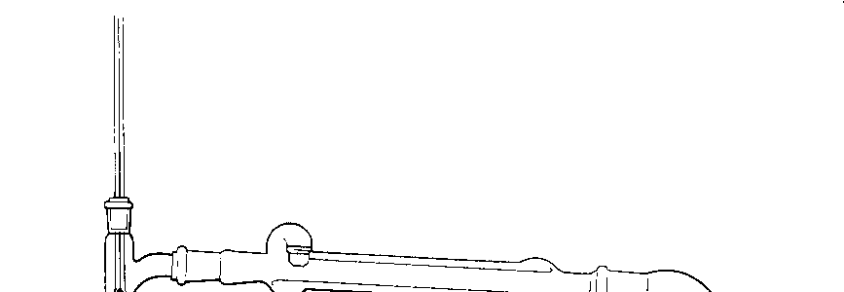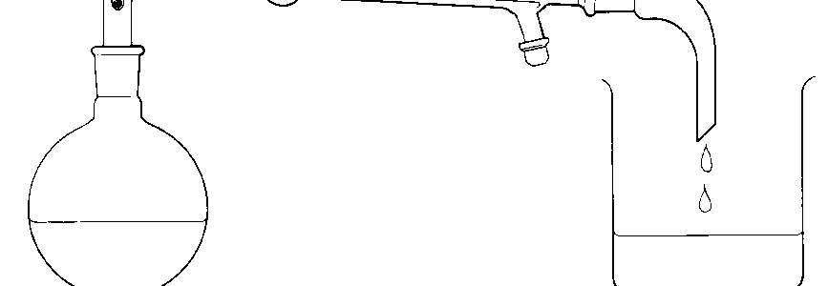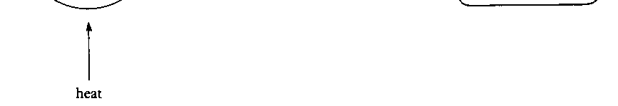
heat

d) On the diagram show where i) vaporisation occurs
ii) condensation occurs.
e) Of what chemicals is the distillate composed? .............................................................................
f) Which has the lower boiling point, water or ethanol (alcohol)? .......................................................

10. Name five substance which are made by using the processes of evaporation or distillation.
..................................................................................................................................................................................................
..................................................................................................................................................................................................
Review Questions

For questions 11 - 18, choose the best alternative.

11. When solutions are filtered there is no
A residue B filtrate C colour

12. Two substances which could be separated by mixing with water and filtering are
A petrol and water B sugar and sand C sugar and water

13. Two substances which cannot be separated by filtration are
A salt and sugar B sand and salt C sugar and chalk

14. Filter paper contains tiny
A traps B holes C sediments D solutes

15. If a solution of salt is filtered, the filtrate is
A salt solution B salt C water

16. The purpose of the condenser in distillation is to
A change a solution into pure water
B cool a vapour so that is changes to a liquid
C evaporate the solvent from a solution
D provide water to make the solution

17. In an experiment, some muddy water was distilled. The substance that condensed in the condenser would be
A distilled mud B the filtrate C water

18. When a suspension of chalk in water is filtered, the filtrate is
A chalk suspension B chalk C water

19. You and your friend decide to produce some drinking water from a bucket of dirty sea water.
a) Your friend says she can get the bits of sea weed and dirt out. What does she do?
b) You say you can remove the salt. What do you do with the sea water to make it tasteless?
c) Your friend claims that sea-salt is better for you than ordinary salt. How would you obtain a sample of dry sea-salt crystals from your sea water?

20. Fill in the gaps:
Filtration
When an insoluble substance is mixed with water, its p................................... remain joined together in grains or lumps. When a soluble substance is mixed with water, its p..................................... move apart.
When filtering a suspension, the suspended (undissolved) substances are trapped on the filter paper to form a r........................ , so the holes in the paper must be s................................. than the lumps in the suspension.
When filtering a dissolved substance, the dissolved particles pass through the holes in the filter paper, so the holes must be l................................ than these particles.
If dissolved substances pass through filter paper, but suspended substances do not, then dissolved particles must be s..................................... than the lumps in a suspension.

21. Three processes used to separate mixtures are: Evaporation Distillation Filtration
Which of the above processes would you use
a) to obtain water from a solution of sugar? ....................................
b) to remove the solid impurities from muddy water? ......................................
c) to separate sand from a mixture of sand and copper sulfate that has been shaken up with water? ............................................
21. d) to obtain solid potassium nitrate from a solution of potassium nitrate? ....................................

22. The lubricating oil in a car engine, during use, becomes mixed with tiny fragments of metal. What method is used within the car to purify the oil?
................................................................

23. After continual use, the cleaning fluid used in dry-cleaning becomes contaminated with suspended
dust and dissolved material (e.g. grease). Suggest how it could be purified.
..................................................................................................................................................................................................
...................................................................................................................................................................................................

24. For each of the following experiments, choose one of the sets of apparatus that is most suitable for carrying out the experiment

boiling
water
filter paper
cold
water
A
B
C
D

a) the separation and collection of pure water from ink
b) the preparation of a mixture rich in alcohol from a mixture containing about equal volumes of alcohol and
water
c) the separation of pieces of cork from a solution of vinegar
d) the separation of solid sulfur from its solution in the liquid xylene
e) the separation of water from a suspension of copper carbonate
f) solid magnesium chloride from a solution of magnesium chloride

25. Label each of the following as true or false. Correct the false statements.
a) Decantation is normally used to separate a filtrate from a solvent
b) Condensation is when a gas cools and forms a liquid
c) In a solution of sugar, water is the solute
d) "To evaporate" means to change a solid into a liquid
e) When a solution of copper sulfate is filtered, the residue obtained is solid copper sulfate.
f) The distillate is the solid left behind after evaporation
g) The filtrate is the liquid which passes through the filter paper
h) A condenser is used to cool down the vapour in distillation
i) Salt would be more soluble in cold water than in boiling water.
j) Petrol is obtained by distilling crude oil.
k) When muddy water is filtered, the residue obtained is water.

